- \Operation\Tube filling\Dosing\Tube filling - dosing – special functions
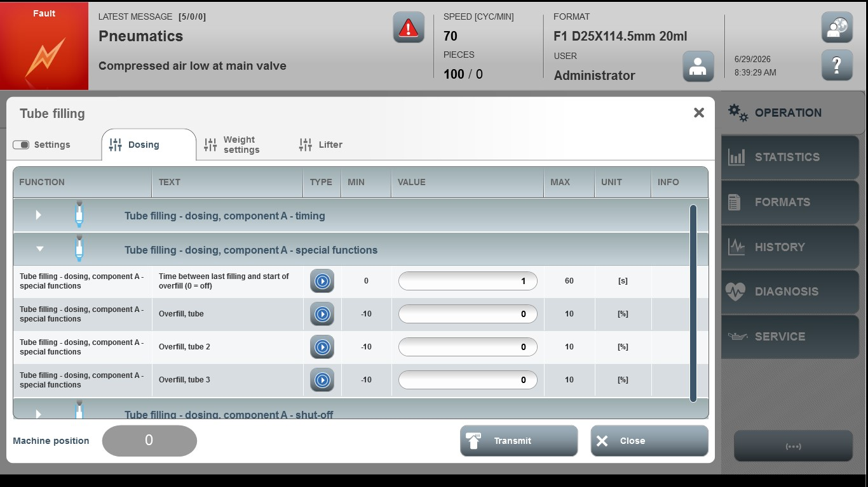
Acceptance criterion | Limits | Pass / Fail: Dev-No. | Date | Initials
Screen matches screenshot | N / A
Time between last filling and start of overfill (0=off) | 0…60
Overfill, tube | -10…10
Over fill, tube2 | -10…10
Over fill, tube3 | -10…10

